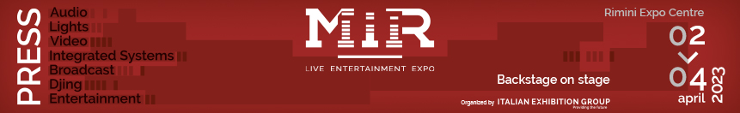
press release
(English translation)

IEG: THE 6TH EDITION OF MIR KICKS OFF TOMORROW IN RIMINI

- From Sunday 2 to Tuesday 4 April, Rimini will host all the major players of the Light, Sound, Visual, Integrated System & Broadcast industry.
- Expo area, immersive rooms and live stage performances showcasing the equipment, technology and solutions of leading brands
- Exclusive formats, meeting spaces, conferences and masterclasses: MIR 2023 is the ideal event for artists, experts and enthusiasts to exchange experiences and knowledge, creating synergies and inspiration
www.mirtechexpo.com
Rimini (Italy), 1 April 2023 – From tomorrow, Sunday 2, to Tuesday 4 April, Rimini will once again be the epicentre of the Light, Sound, Visual, Integrated System & Broadcast industry. The Expo Centre will open its doors for the 6th edition of MIR, the event organised by Italian Exhibition Group that brings together under one roof all the leading players in these sectors, giving an international reach to a local area with a longstanding tradition in live entertainment. The top-drawer companies will unveil innovative solutions and technologies to the thousands of eager operators.

AN UNMISSABLE OPPORTUNITY TO SEE AND TEST
Save the date because this year, MIR has pulled out all the stops, occupying six halls – with a total of over 17,000 sqm- where visitors can get up close and test the products and latest updates from the main world international brands. And there’s more: in the MIR TECH specialised area, you’ll find a series of exclusive formats – like installations in the AV Experience area for a 360° immersion in the audio video universe – and a jam-packed calendar with a host of partners, acclaimed experts, and professionals from the industry.

MIR IS “LIVE YOU PLAY”
One of the main attractions is the “Live you Play” format, with two fully equipped stages simulating the audio, video, and lighting of real live performances. “Live System Contest” and “Contest Mixer” will compare audio and mixer systems on an innovative robotised stage that optimises sound performance. The crowd-pleasing IMMERSIVE ROOMS are back again, delivering an immersive sound experience, while in the SOUND ARENA, the “Contest Colonne” will provide comparative of high-quality vertical audio systems.

MIR CLUB AND CAREER DAY
MIR CLUB is also about active participation with artists and makers in the field of innovation and live event production, making new contacts and creating synergies. The club will host discussions, meetings and talks, live performances and DJ sets. “Career Day” will be held on Monday 3 April: those interested in being a part of this world can schedule a one-to-one speed meeting with some of the most acclaimed producers, entrepreneurs, sound designers, safety experts and figures in live entertainment.

BIG NAMES IN THE CLUB ARENA: TECHNOLOGY AT THE SERVICE OF EMOTIONS
The CLUB ARENA will hold conferences focusing on the themes of show business, the challenges it faces and how technology is at the service of emotions. Plenty of scope for training events as well, with important masterclasses, among others, lighting designer, Marco Filibeck (“Light speaks”) and Giovanni Pinna (“Lighting design in live shows – Design and creation”), producer and sound engineer, Alex Trecarichi (“BetterMakers – Tricks and techniques to improve mixing and production”) and journalist and music, Pierfrancesco Pacoda (“Festival and local area – how can music foster cultural and economic development in the areas that host it?”).
Monday at 10.30am, the conference, “The impact of technology on the design of spaces”, in collaboration with SIEC - Systems Integration Experience Community, and open to architects, designers, IT and marketing managers, and anyone involved in the design of spaces for work, training, entertainment, hospitality, immersivity and retail.

For the complete list of companies participating, and the full MIR 2023 programme, visit www.mirtechexpo.com
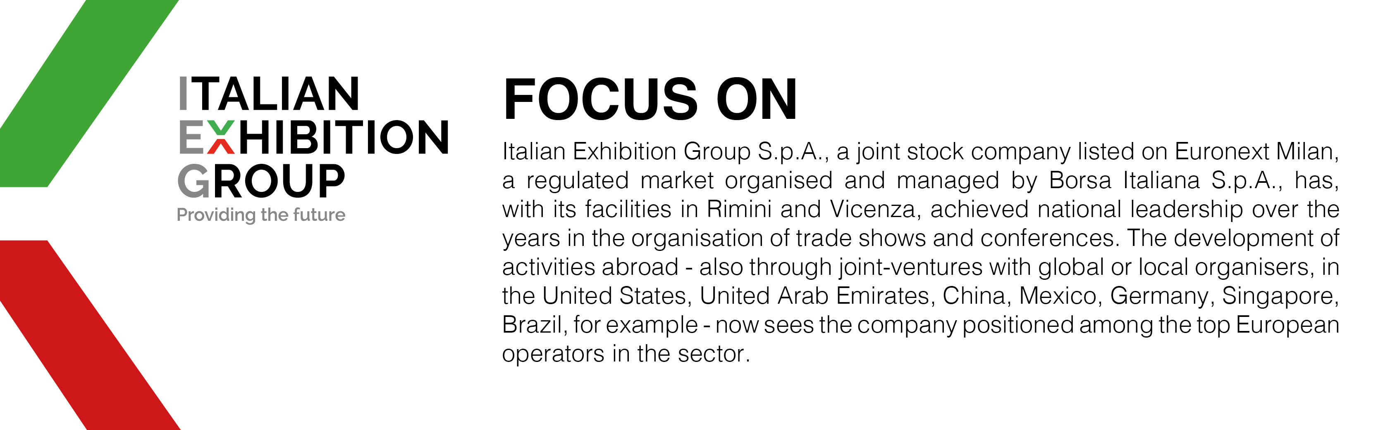

MIR 2023 AT A GLANCE
Organisation: Italian Exhibition Group SpA; Recurrence: annual; Edition: 6th; Open to: professional operators and general public; website: www.mirtechexpo.com

PRESS CONTACT ITALIAN EXHIBITION GROUP
Head of media relations & corporate communication: Elisabetta Vitali
Press office manager: Marco Forcellini
International press office coordinator: Silvia Giorgi

MEDIA AGENCY MIR
Naper Multimedia| Zoe Perna | T. +39 02 97699600 | email: staff@napermultimedia.it

This press release contains forecast elements and estimates that reflect the management’s current opinions (“forward-looking statements”), particularly regarding future management performance, realization of investments, cash flow trends and the evolution of the financial structure. For their very nature, forward-looking statements have a component of risk and uncertainty, as they depend on the occurrence of future events. The effective results may differ (even significantly) from those announced, due to numerous factors, including, only by way of example: food service market and tourist flow trends in Italy, gold and jewellery market trends, green economy market trends; the evolution of raw material prices; general macroeconomic conditions; geopolitical factors and evolutions in the legislative framework. Moreover, the information contained in this release does not claim to be complete, and has not been verified by independent third parties. Forecasts, estimates and objectives contained herein are based on the information available to the Company as at the date of this release.

